- Rpi install
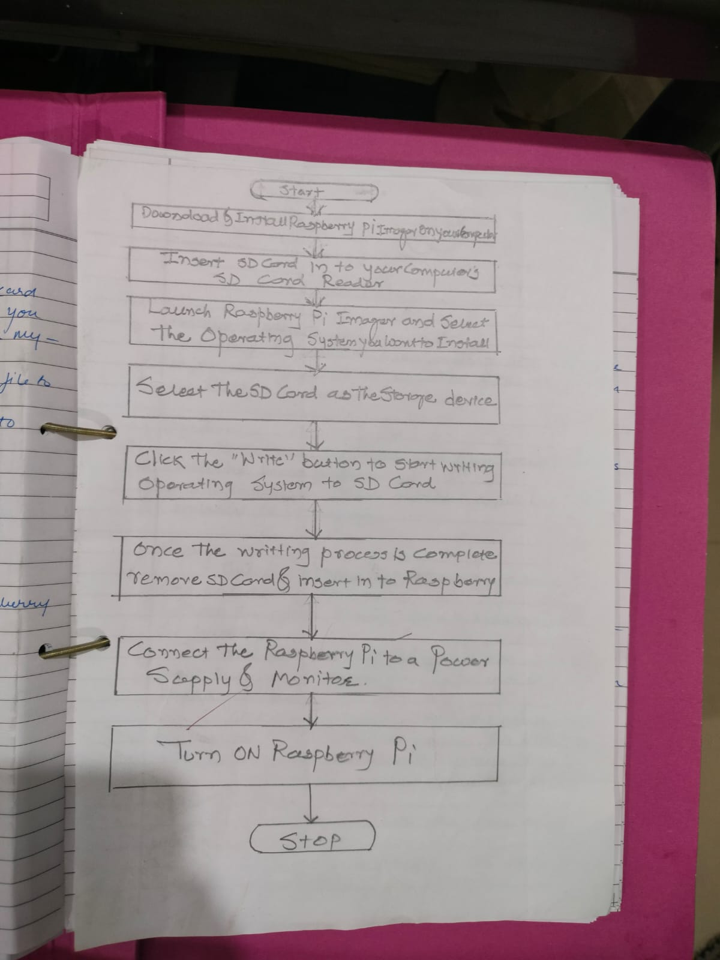

- R pi switch LED
Code:
importRPi.GPIO as GPIO
GPIO.setmode(GPIO.BCM)
GPIO.setup(17, GPIO.OUT)
GPIO.setup(22, GPIO.IN)

while True:
ifGPIO.input(22):
GPIO.output(17, GPIO.HIGH)
else:
GPIO.output(17, GPIO.LOW)

GPIO.cleanup()
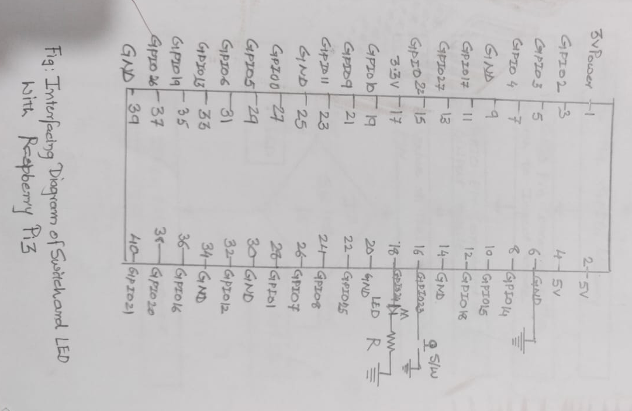
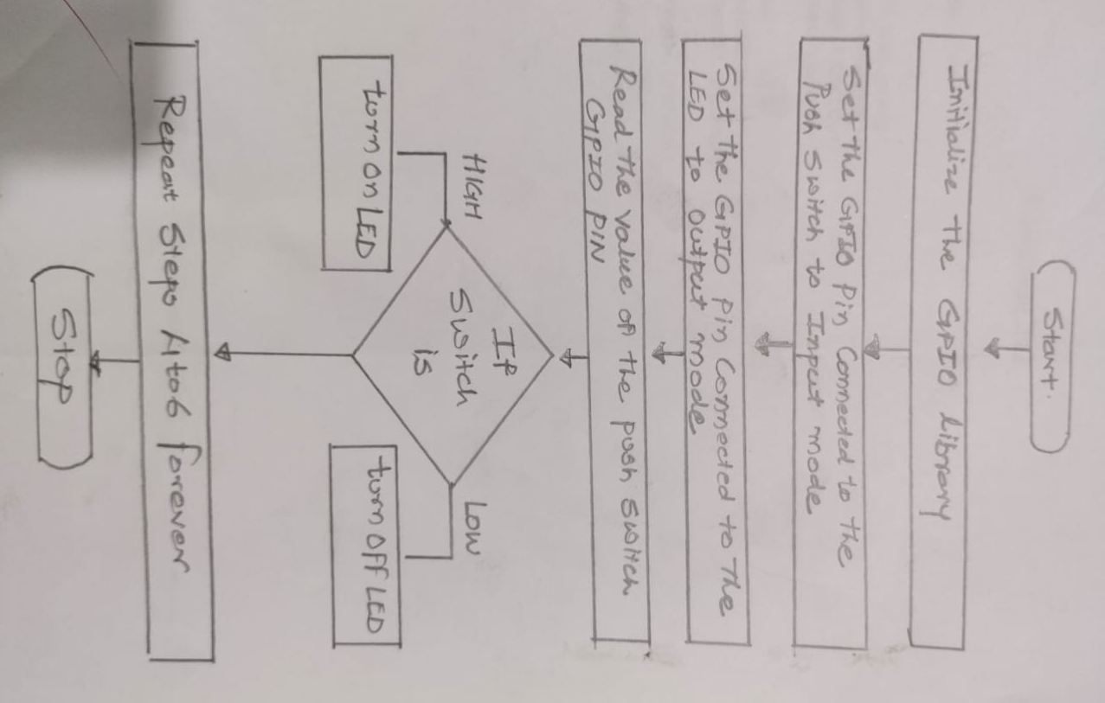
  - Temperature sensors(LM35) with Arduino
Code:
const int lm35_pin = A1; /* LM35 O/P pin */

void setup() {
Serial.begin(9600);
}

void loop() {
int temp_adc_val;
float temp_val;
temp_adc_val = analogRead(lm35_pin); /* Read Temperature */
temp_val = (temp_adc_val * 4.88); /* Convert adc value to equivalent voltage */
temp_val = (temp_val/10); /* LM35 gives output of 10mv/°C */
Serial.print("Temperature = ");
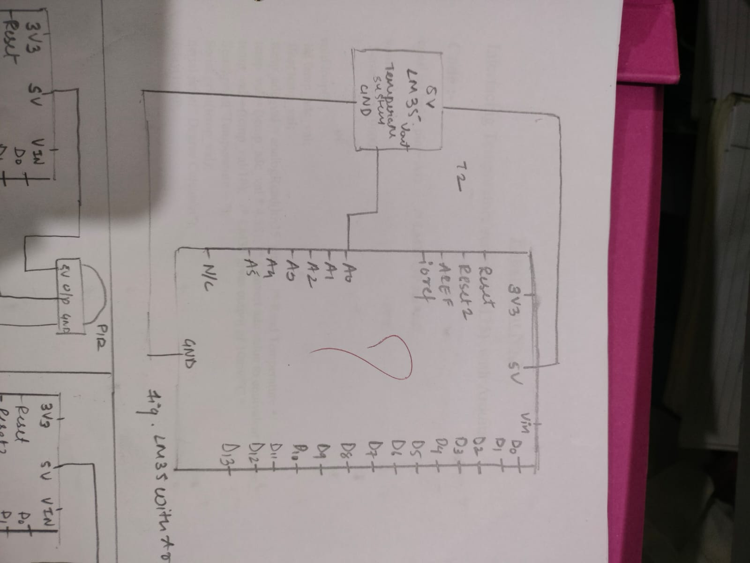
Serial.print(temp_val);
Serial.print(" Degree Celsius\n");
delay(1000);}

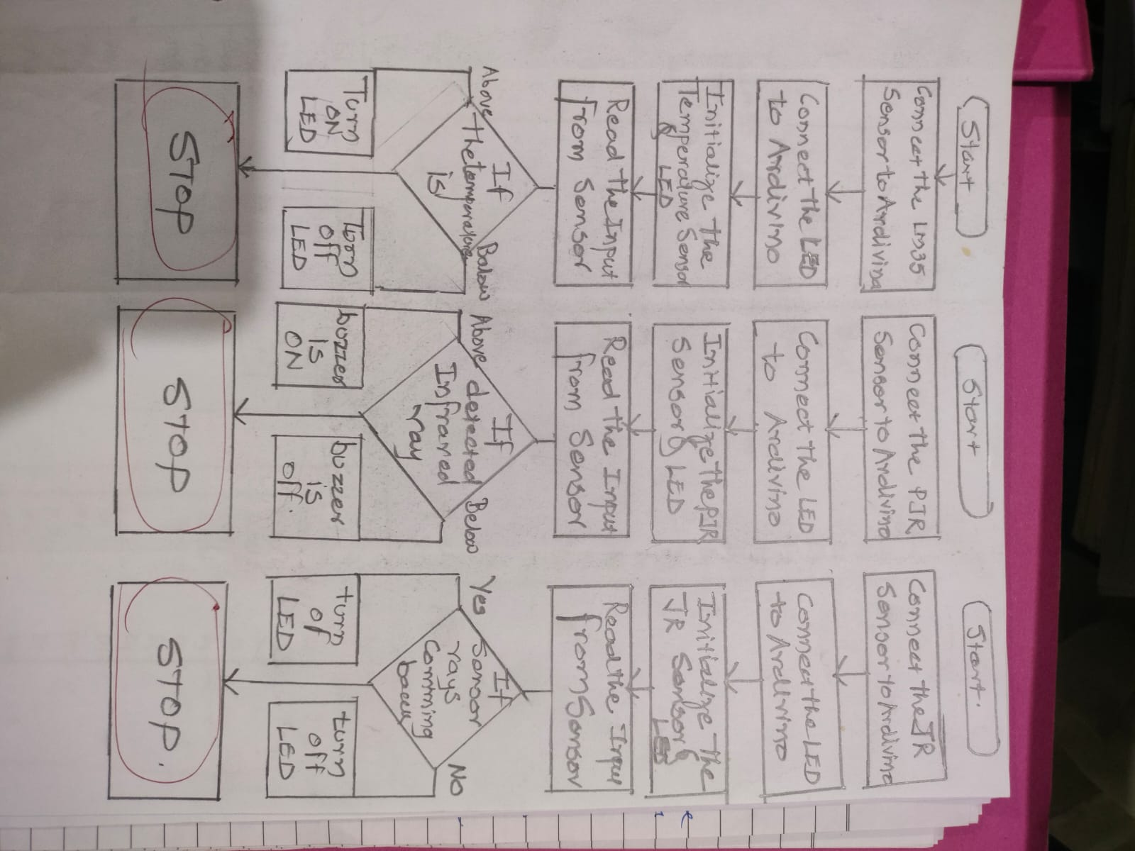
  - Interfacing IR sensors with Arduino

Code :-
int IRSensor = 9; // connect ir sensor module to Arduino pin 9
int LED = 13; // conect LED to Arduino pin 13
void setup()
{
Serial.begin(115200); // Init Serila at 115200 Baud
Serial.println("Serial Working"); // Test to check if serial is working or not
pinMode(IRSensor, INPUT); // IR Sensor pin INPUT
pinMode(LED, OUTPUT); // LED Pin Output
}
void loop()
{
int sensorStatus = digitalRead(IRSensor); // Set the GPIO as Input
if (sensorStatus == 1) // Check if the pin high or not
{
// if the pin is high turn off the onboard Led
digitalWrite(LED, LOW); // LED LOW
Serial.println("Motion Ended!"); // print Motion Detected! on the serial monitor window
}
else
{
//else turn on the onboard LED
digitalWrite(LED, HIGH); // LED High
Serial.println("Motion Detected!"); // print Motion Ended! on the serial monitor window
}
}

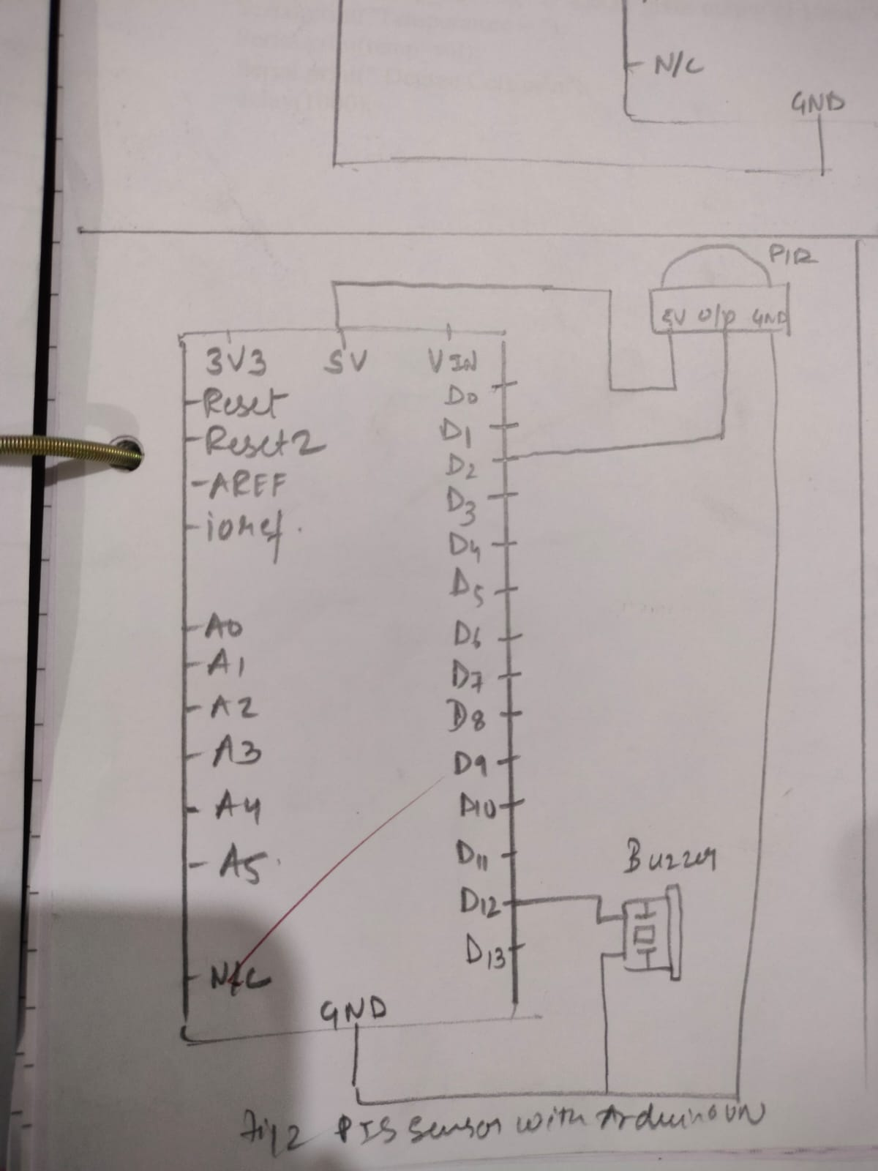
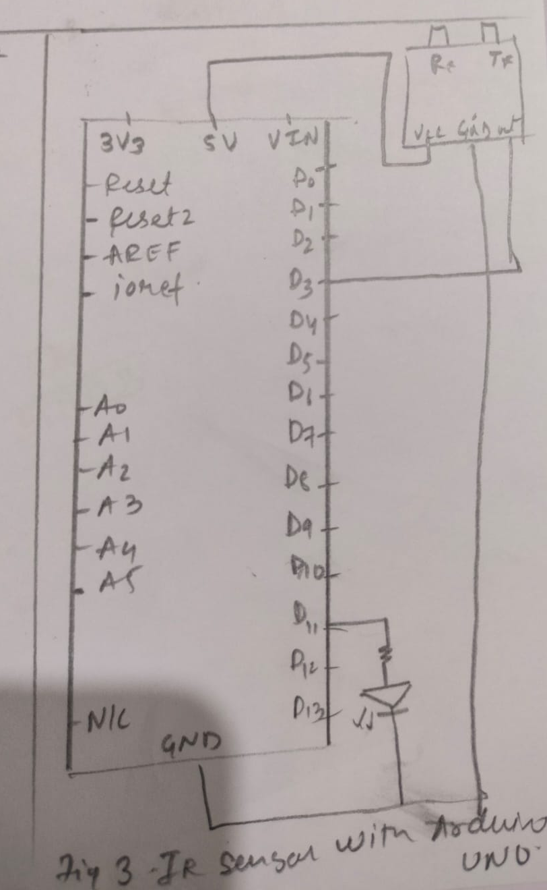

3.3 Interfacing PIR sensors with Arduino

Code :-
int ledPin = 13; // choose the pin for the LED
int inputPin = 8; // choose the input pin (for PIR sensor)
int pirState = LOW; // we start, assuming no motion detected
int val = 0; // variable for reading the pin status
void setup() {
pinMode(ledPin, OUTPUT); // declare LED as output
pinMode(inputPin, INPUT); // declare sensor as input
Serial.begin(9600);
}
void loop(){
val = digitalRead(inputPin); // read input value

if (val == HIGH) // check if the input is HIGH
{
digitalWrite(ledPin, HIGH); // turn LED ON
if (pirState == LOW)
{
Serial.println("Motion detected!"); // print on output change
pirState = HIGH;
}
}
else
{
digitalWrite(ledPin, LOW); // turn LED OFF
if (pirState == HIGH)
{
Serial.println("Motion ended!"); // print on output change
pirState = LOW;
}
}
}

4.1 Stepper motor

Code :-

importRPi.GPIO as GPIO
from time import sleep
import sys
#assign GPIO pins for motor
motor_channel = (29,31,33,35)
GPIO.setwarnings(False)
GPIO.setmode(GPIO.BOARD)
#for defining more than 1 GPIO channel as input/output use
GPIO.setup(motor_channel, GPIO.OUT)
motor_direction = input('select motor direction a=anticlockwise, c=clockwise: ')
while True:
try:
if(motor_direction == 'c'):
print('motor running clockwise\n')
GPIO.output(motor_channel, (GPIO.HIGH,GPIO.LOW,GPIO.LOW,GPIO.HIGH))
sleep(0.02)
GPIO.output(motor_channel, (GPIO.HIGH,GPIO.HIGH,GPIO.LOW,GPIO.LOW))
sleep(0.02)
GPIO.output(motor_channel, (GPIO.LOW,GPIO.HIGH,GPIO.HIGH,GPIO.LOW))
sleep(0.02)
GPIO.output(motor_channel, (GPIO.LOW,GPIO.LOW,GPIO.HIGH,GPIO.HIGH))
sleep(0.02)

elif(motor_direction == 'a'):
print('motor running anti-clockwise\n')
GPIO.output(motor_channel, (GPIO.HIGH,GPIO.LOW,GPIO.LOW,GPIO.HIGH))
sleep(0.02)
GPIO.output(motor_channel, (GPIO.LOW,GPIO.LOW,GPIO.HIGH,GPIO.HIGH))
sleep(0.02)
GPIO.output(motor_channel, (GPIO.LOW,GPIO.HIGH,GPIO.HIGH,GPIO.LOW))
sleep(0.02)
GPIO.output(motor_channel, (GPIO.HIGH,GPIO.HIGH,GPIO.LOW,GPIO.LOW))
sleep(0.02)
#press ctrl+c for keyboard interrupt except KeyboardInterrupt:
#query for setting motor direction or exit
motor_direction = input('select motor direction a=anticlockwise, c=clockwise or q=exit: ')
#check for exit
if(motor_direction == 'q'):
print('motor stopped')
sys.exit(0)
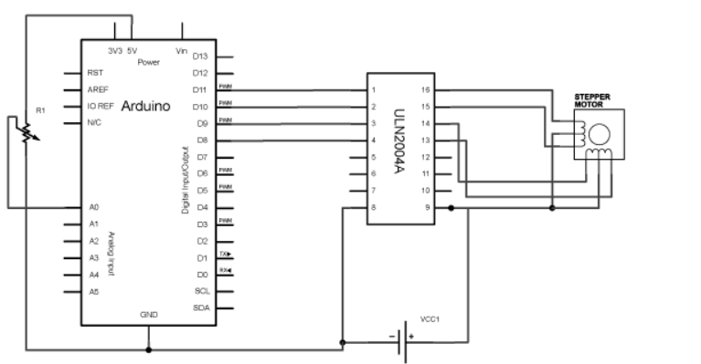

4.2 Arduino DC motor speed control
Code:
#define enA 9
#define in1 6
#define in2 7

void setup() {
pinMode(enA, OUTPUT);
pinMode(in1, OUTPUT);
pinMode(in2, OUTPUT);

// Set initial rotation direction
digitalWrite(in1, LOW);
digitalWrite(in2, HIGH);
}

void loop() {
int potValue = analogRead(A0); // Read potentiometer value
int pwmOutput = map(potValue, 0, 1023, 0 , 255);
// Map the potentiometer value from 0 to 255
analogWrite(enA, pwmOutput); // Send PWM signal to L298N Enable pin
digitalWrite(in1, HIGH);
digitalWrite(in2, LOW);
delay(20);
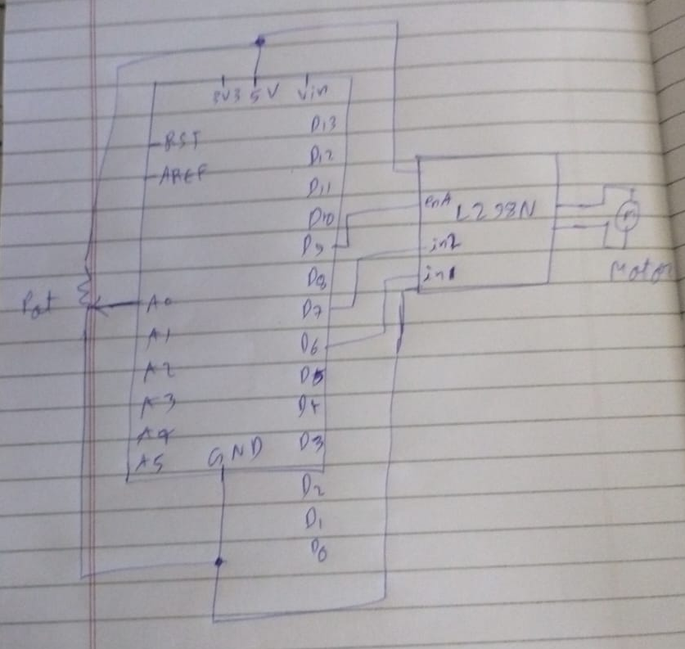
}

5) MQTT

write this code in python IDE or directly from terminal of Raspberry PI

Code :-
# ThingSpeak Update Using MQTT
# Compiled by Ashish Kumar (ashishmarch12@gmail.com) # Date: 07 April 2018

from future import print_function import paho.mqtt.publish as publish import psutil
import sys
import Adafruit_DHT import time

# Replace this with your Channel ID
channelID = "XXXXXX"
# The Write API Key for the channel
apiKey = "XXXXXXXXXXXXXXXX"

# MQTT Connection Methods useUnsecuredTCP = True useUnsecuredWebsockets = False useSSLWebsockets = False

# The Hostname of the ThinSpeak MQTT service
mqttHost = "mqtt.thingspeak.com"

# MQTT connection parameters
if useUnsecuredTCP: tTransport = "tcp" tPort = 1883
tTLS = None
if useUnsecuredWebsockets: tTransport = "websockets" tPort = 80
tTLS = None

if useSSLWebsockets: import ssl
tTransport = "websockets"
tTLS = {'ca_certs':"/etc/ssl/certs/ca-certificates.crt",'tls_version':ssl.PROTOCOL_TLSv1} tPort = 443

# Create the topic string
topic = "channels/" + channelID + "/publish/" + apiKey

while(True):
humidity, temperature = Adafruit_DHT.read_retry(11, 4) print("Temperature = %s Humidity = %s" % (temperature, humidity)) tPayload = "field1=" + str(temperature) + "&field2=" + str(humidity)
time.sleep(10) try:
publish.single(topic, payload=tPayload, hostname=mqttHost, port=tPort, tls=tTLS, transport=tTransport)

except (KeyboardInterrupt):
break

except:
print ("There was an error while publishing the data.")

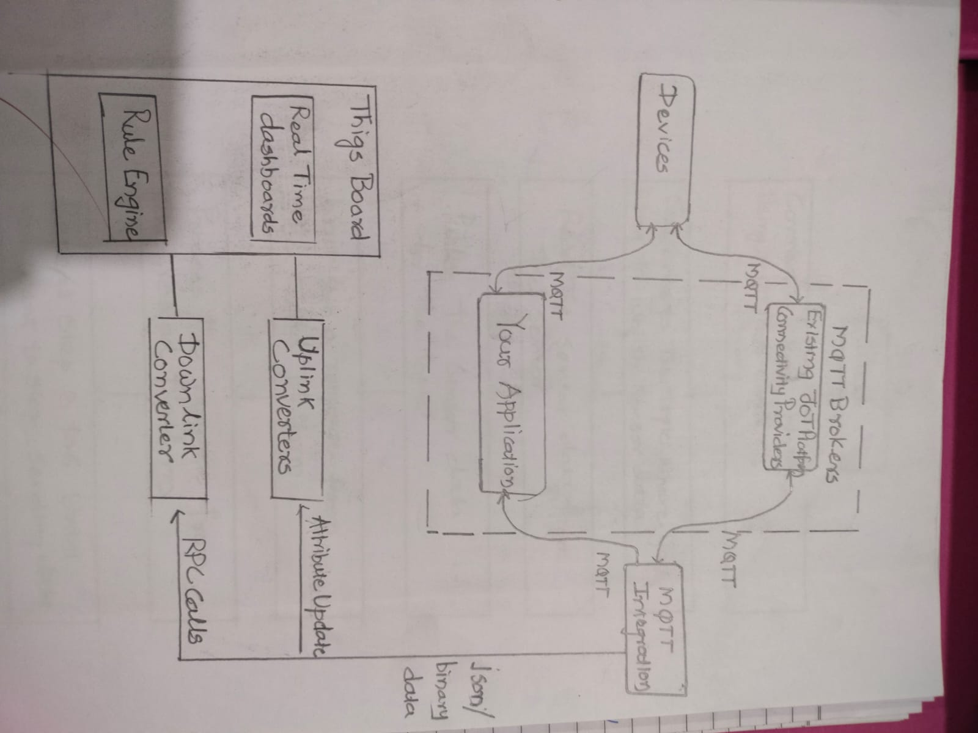
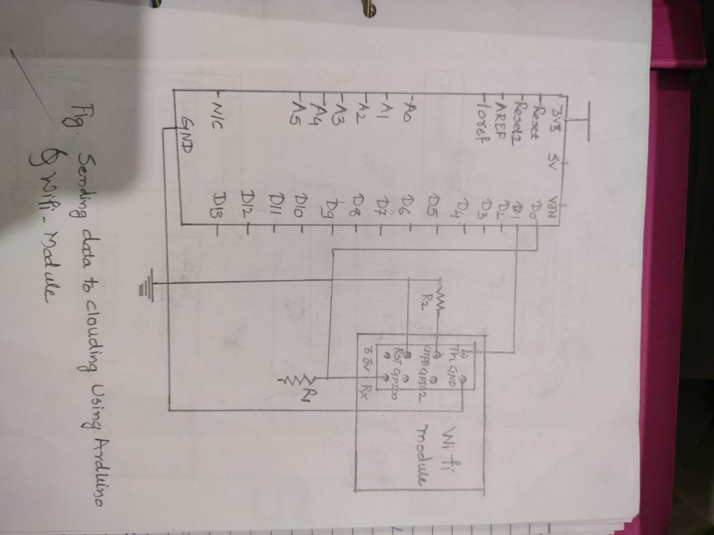
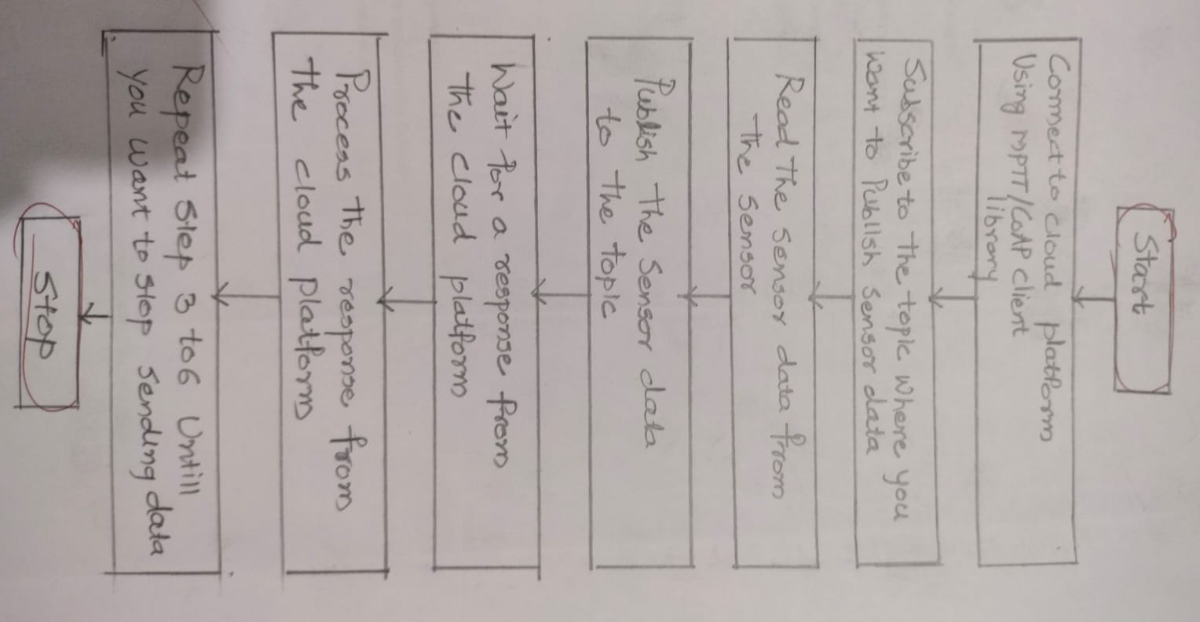

6) Web server Rpi LED
Below is the complete code for creating two buttons to turn on and off the LED connected to Raspberry Pi.

Code :-
<html>
<head>
<meta name="viewport" content="width=device-width" />
<title>Raspberry Pi WiFi Controlled LED</title>
</head>
<body>
<center><h1>Control LED using Raspberry Pi Webserver</h1>
<form method="get" action="index.php">
<input type="submit" style = "font-size: 14 pt" value="OFF" name="off">
<input type="submit" style = "font-size: 14 pt" value="ON" name="on">
</form>​​​
</center>
<?php
shell_exec("/usr/local/bin/gpio -g mode 27 out");
if(isset($_GET['off']))
{
echo "LED is off";
shell_exec("/usr/local/bin/gpio -g write 27 0");
}
else if(isset($_GET['on']))
{
echo "LED is on";
shell_exec("/usr/local/bin/gpio -g write 27 1");
}
?>
</body>
</html>

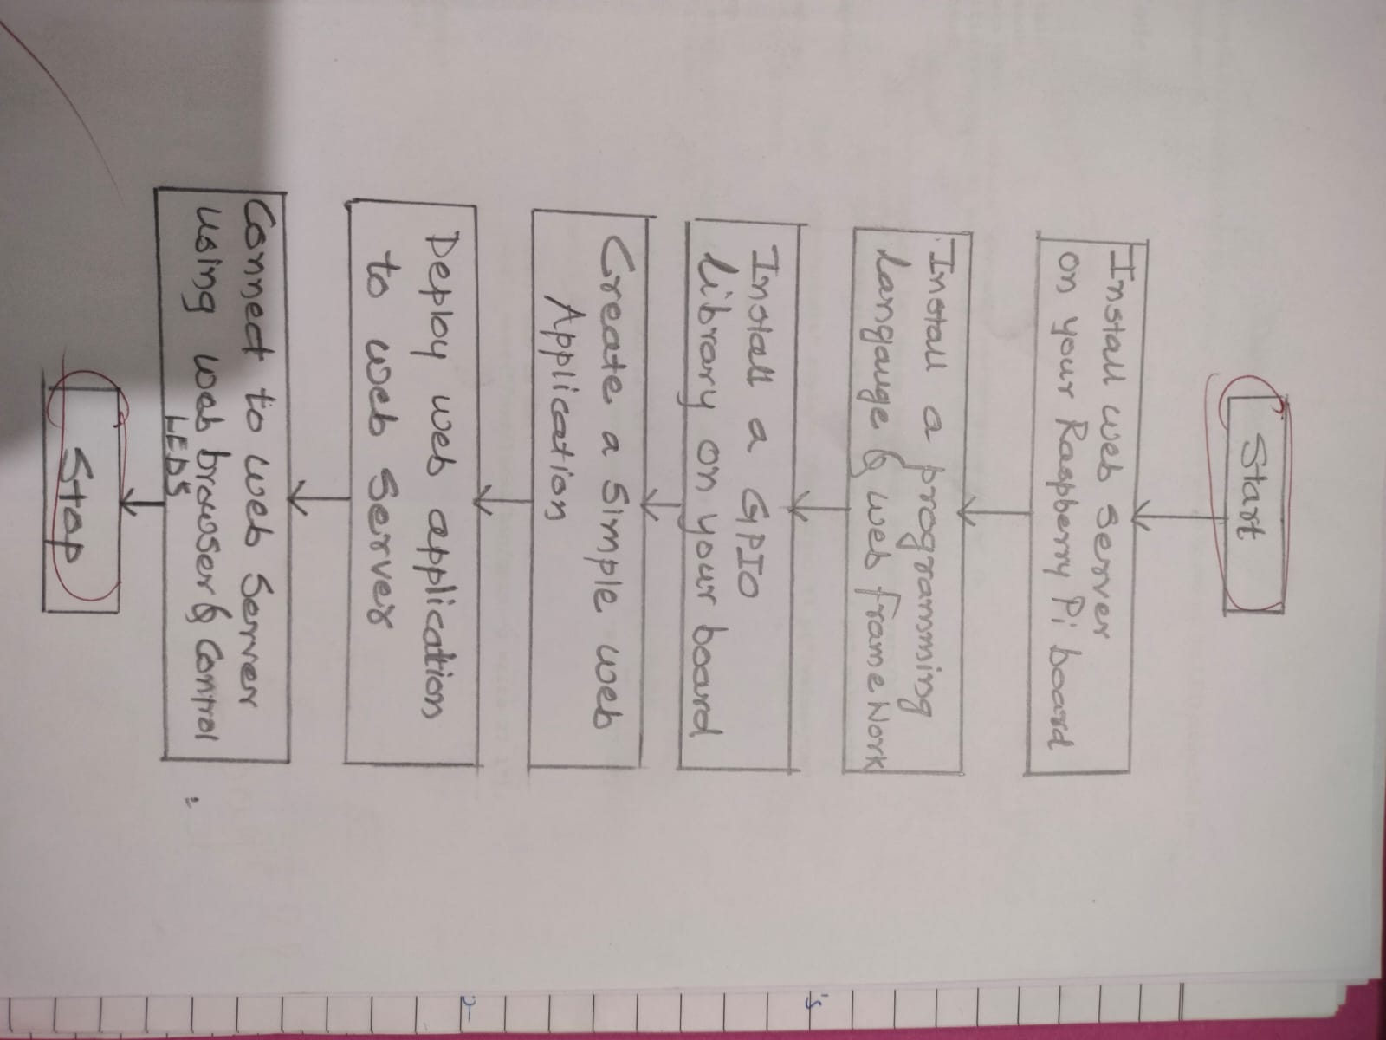
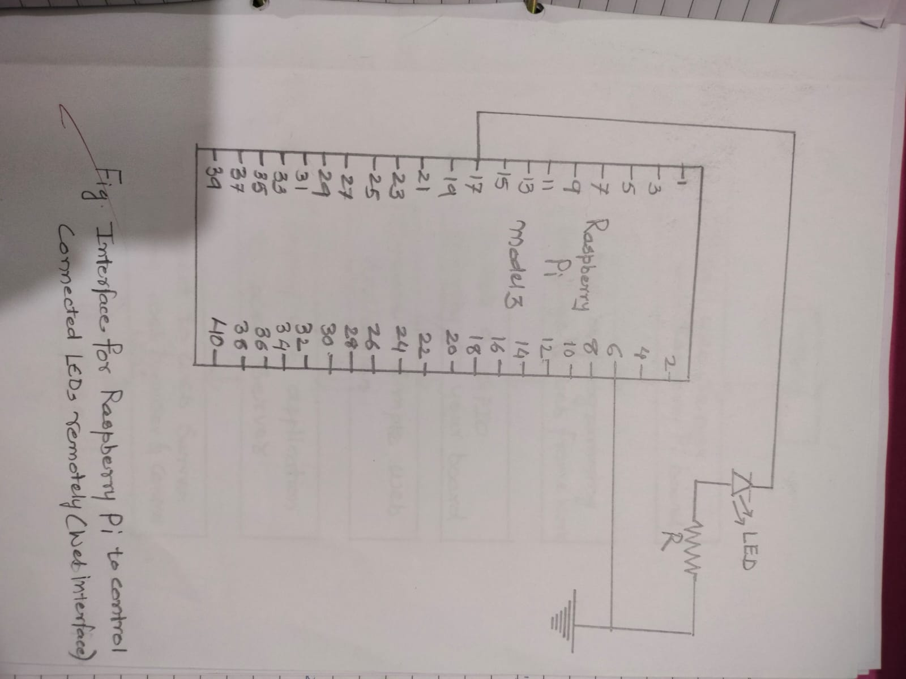

7) Bluetooth

Code :-
char data = 0; //Variable for storing received data
void setup()
{
Serial.begin(9600); //Sets the data rate in bits per second (baud) for serial data transmission
pinMode(13, OUTPUT); //Sets digital pin 13 as output pin
}
void loop()
{
if(Serial.available() > 0) // Send data only when you receive data:
{
data = Serial.read(); //Read the incoming data and store it into variable data
Serial.print(data); //Print Value inside data in Serial monitor
Serial.print("\n"); //New line
if(data == '1') //Checks whether value of data is equal to 1
digitalWrite(13, HIGH); //If value is 1 then LED turns ON
else if(data == '0') //Checks whether value of data is equal to 0
digitalWrite(13, LOW); //If value is 0 then LED turns OFF
}
}

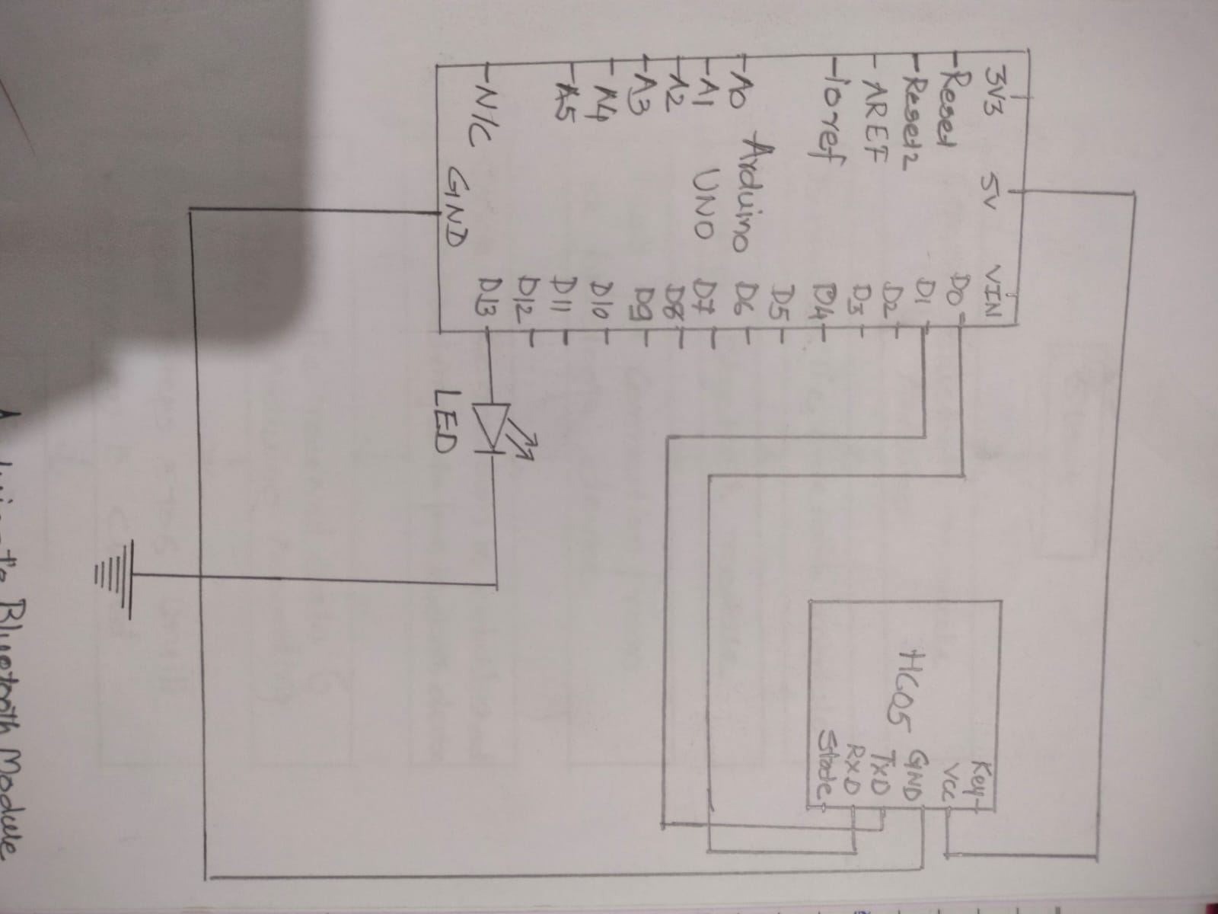

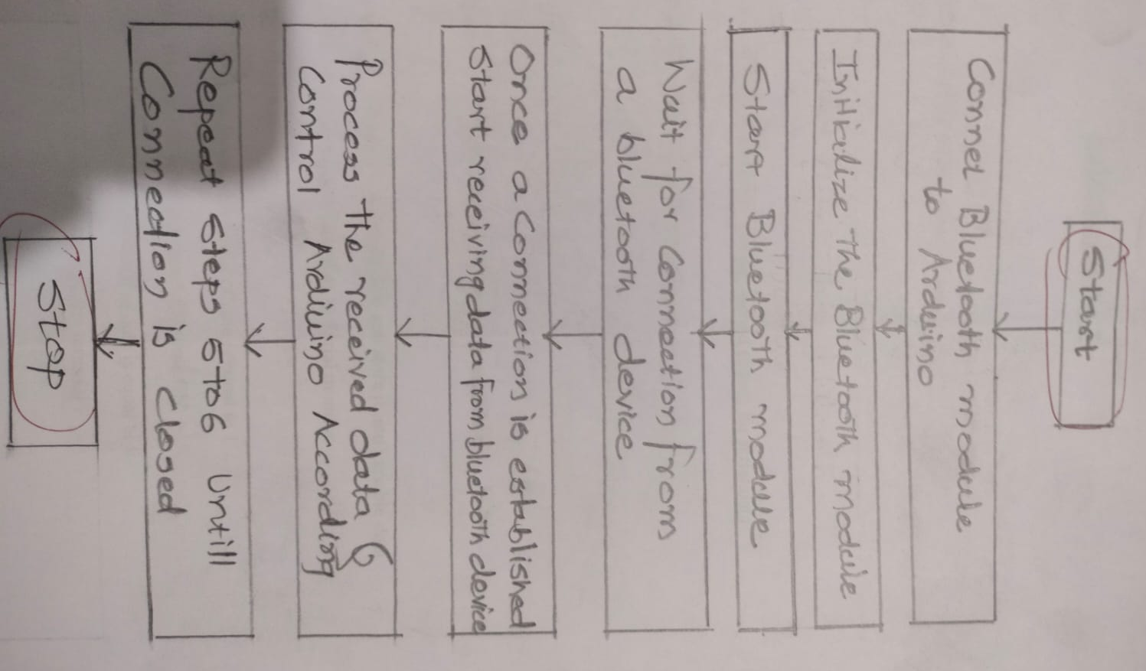

8) Zigbee
Upload this code to your Arduino

Code :-

int ledPin = 13;void setup() {
Serial.begin( 9600 ); // baud rate 9600 for the serial Bluetooth communication
}void loop() {
// listen for the data from raspberry pi
if ( Serial.available() > 0 ) {
// read a numbers from serial port
int inputVal = Serial.parseInt(); if (inputVal > 0) {
Serial.print("Your input is: ");
Serial.println(String(inputVal));
// Here blink the LED
blinkLED(inputVal);
}
}
}void blinkLED(int inputVal) {
for (int i=0; i< inputVal; i++) {
digitalWrite(ledPin, HIGH);
delay(500);
digitalWrite(ledPin, LOW);
delay(500);
}
}
